MGA
Install
AOC Software installation guide


UK tel: 07791 466201

MGAsoftware.com | Active Spreadsheet Technology for the aviation sector

Getting Started
To install from a Compact Disc supplied by MGAsoftware.com:
Place the CD you have received from MGA software in your CD/DVD drive.
The installation process should commence automatically so that you see the welcome screen at 1 below.
If you don’t see the screen below, click the ‘My Computer’ icon on your desktop (also available via Start → Programs → Accessories → Windows Explorer).
In ‘My Computer’ click the icon for your CD drive
(Look for the label ‘AOC System Demo’)
To run the installer click on: MGAsoftwareDemo.msi
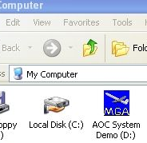
1 Install Welcome screen.
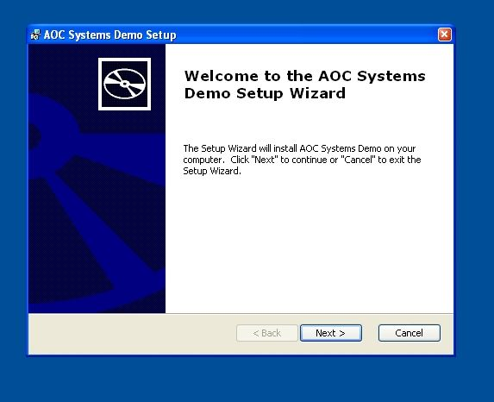
When ready, Click ‘Next’

Getting Started cont.
2 Select Installation Folder
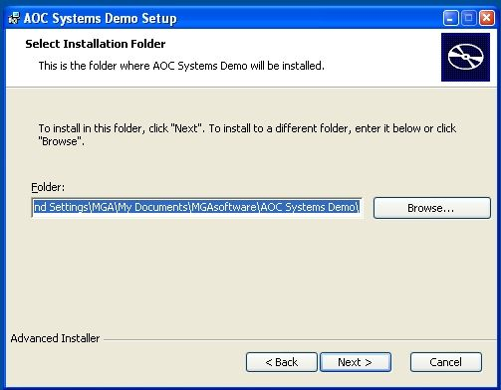
Accept the default folder and click ‘Next’
(unless you wish to install the software in a folder of your choice).
The default folder will be in the personal folder for the current User Account.
3 Ready to Install
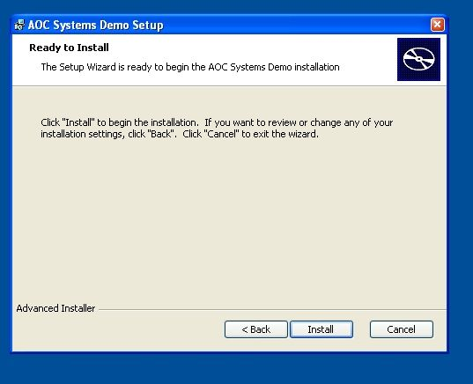
When ready, Click ‘Next’

Getting Started cont
4
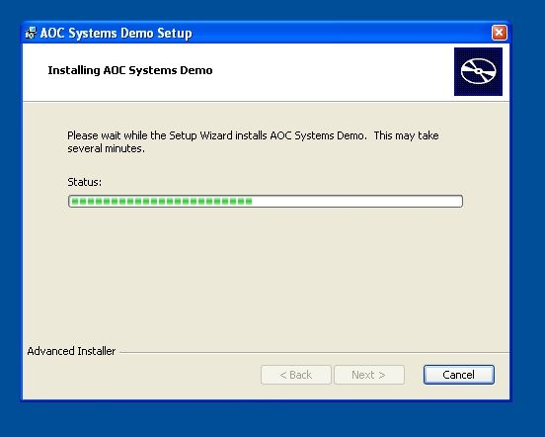
5
When installation is complete, click ‘Finish’ to exit the installer.
An icon will be placed on your desktop
labelled ‘AOC Systems Demo’
Click on it to run Microsoft Excel and call up your MGA software.
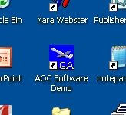

Enabling macros on First Run
MGA software uses program codes called 'macros'. For these to run, Excel’s Security Settings require that macros be enabled (by default macros are disabled). When MGA software is first run you will get an error message if macros are not enabled. MGA software contains no harmful code and if no other factors preclude it, we recommend that security settings be reduced.
If a message like those below appears on start-up:
In Excel BEFORE 2007:
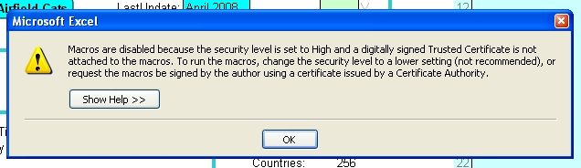
Click Tools | Macro | Security … select medium or low security level:
Security Level settings in pre-2007 Excel
If set to High or Very High, MGA software will not run.
If set to Medium, a warning (‘macros can contain viruses’) will appear every time MGA software is run and your will have to click the ‘Enable Macros’ option each time.
If set to Low (recommended), MGA software will run without interruption.

After enabling Macros, Excel must be shut down and restarted.
Close Excel by clicking the ‘X’ at top right.
In Excel version 2007:
Macro Warning message in Excel 2007:
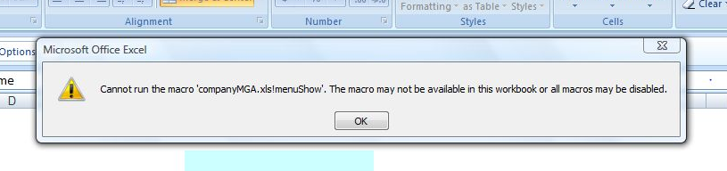

In Excel version 2007 cont:
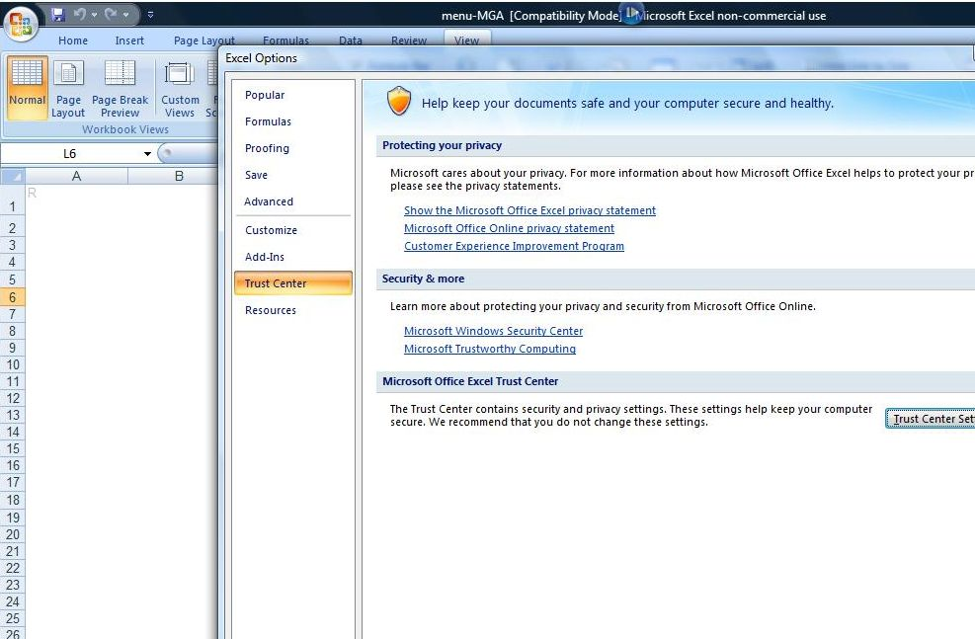
1
2
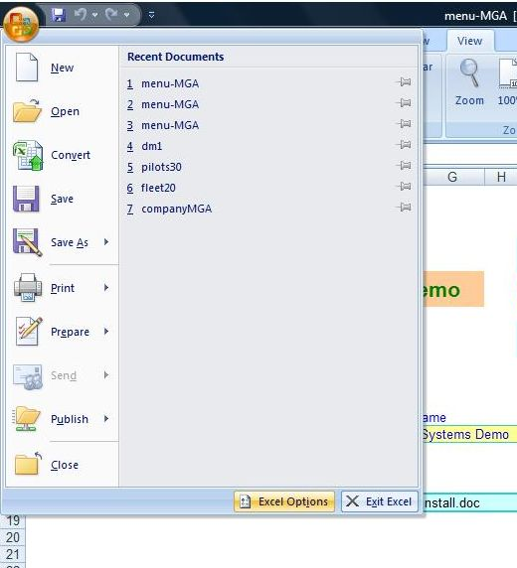
1 Click Excel Options

2 Click Trust Center

2
3
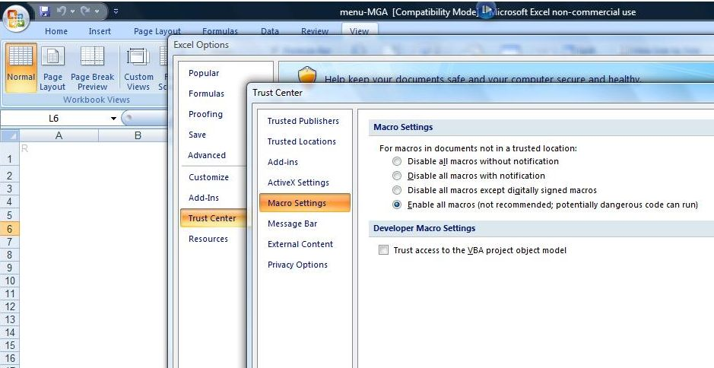
3 Macro Settings Select Enable macros

Alternatively Click Trusted Locations, then choose the option Add a trusted location - specify the MGA folder as a trusted location. This will permit MGA macros only instead of globally enabling macros.

Menu
If you have a demo your menu will display ‘AOC Systems Demo’ as above.
Otherwise your own company name and logo will be shown.
To exit from the MGA system completely, click the Close button.
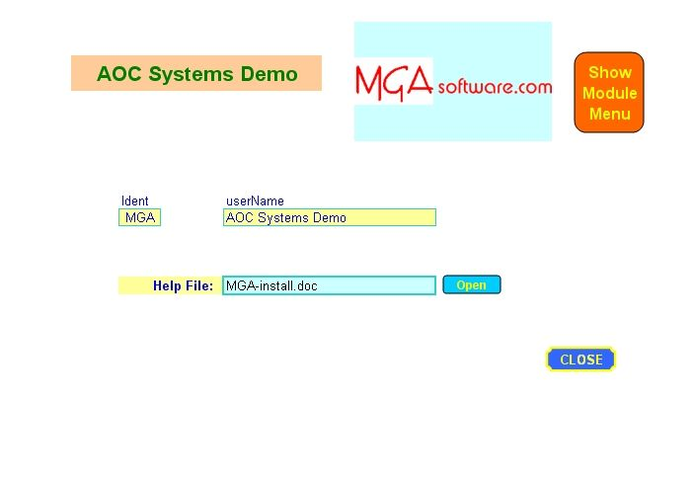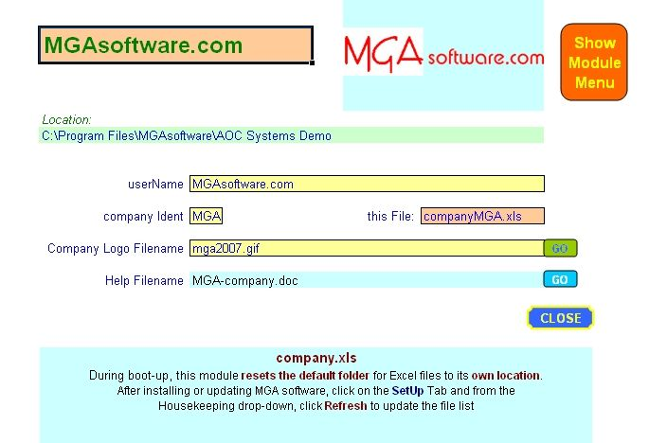
Click the Show Module Menu button to bring up the menu overlay.
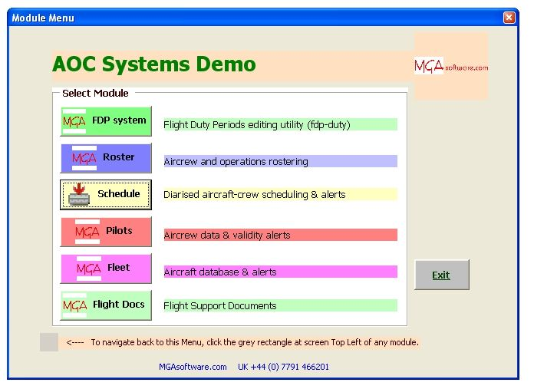
Click the Exit button to close the Menu overlay.
Click on a button to navigate to an MGA module.
(Note only ‘licensed’ modules are available)

Navigation 1
To Navigate within a module  Click on the TABs at screen bottom to navigate to a different screen (or Excel ‘Sheet’).  (Note: Refer to the indivudal module manuals for more detailed information)  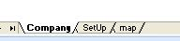 | To navigate back to the menu  Click on the small grey rectangle at screen  Top Left of your MGA module  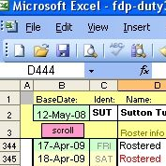
To navigate between modules
Click Close to close the current module. If you get a prompt to Save changes, click Yes (the default). Note closing a module releases memory and can improve performance of your computer  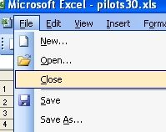 |  | You can use Excel to change between open modules:  In Excel 2007, from the ‘View‘ Tab click ‘Switch Windows’  (In Excel 2003, click ‘Window’)  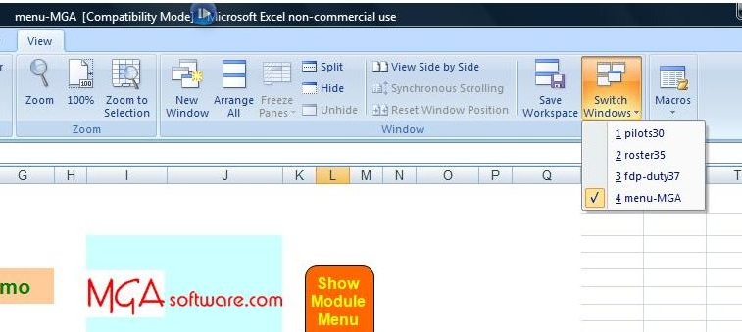
Protection
MGA programs switch on Excel’s inbuilt protection in order to conserve important data. There are times when you might want to remove protection (to edit a cell for example).
In Excel 2003 you can do this by clicking Unprotect from the Tools menu.
In Excel 2007 (right), protection is switched via the ‘Review’ Tab.
Edit
To edit in Excel, position the cursor in the required cell and hit the F2 key (Function 2).
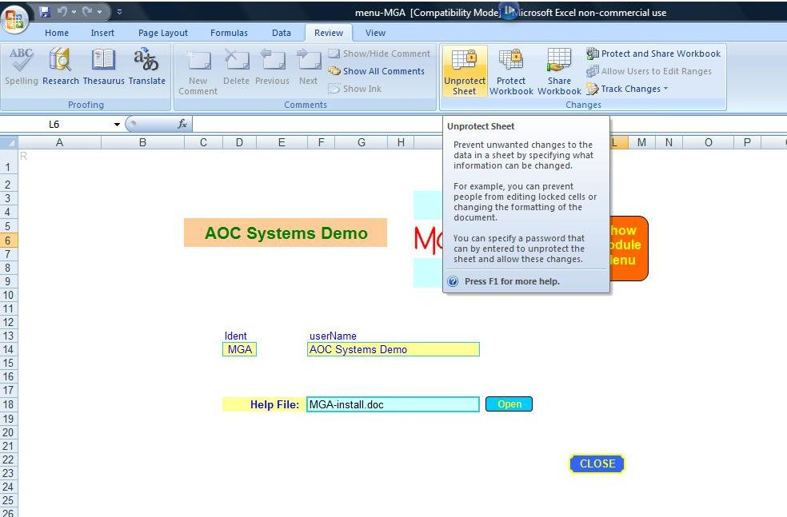

Navigation 2
Excel 2007 Compatibility Mode
MGA software systems work on any Excel version from Excel 97 on. If you are using Excel 2007, MGA programs will automatically open in what is called ‘Compatibility Mode’. This is perfectly normal.
When using Excel 2007 you will get a warning of ‘Significant loss of functionality’ each time you go to Save a file. This may be safely disregarded.
To stop the warning showing again uncheck the box labelled
’Check compatibility when saving this workbok’
and click ‘Continue’
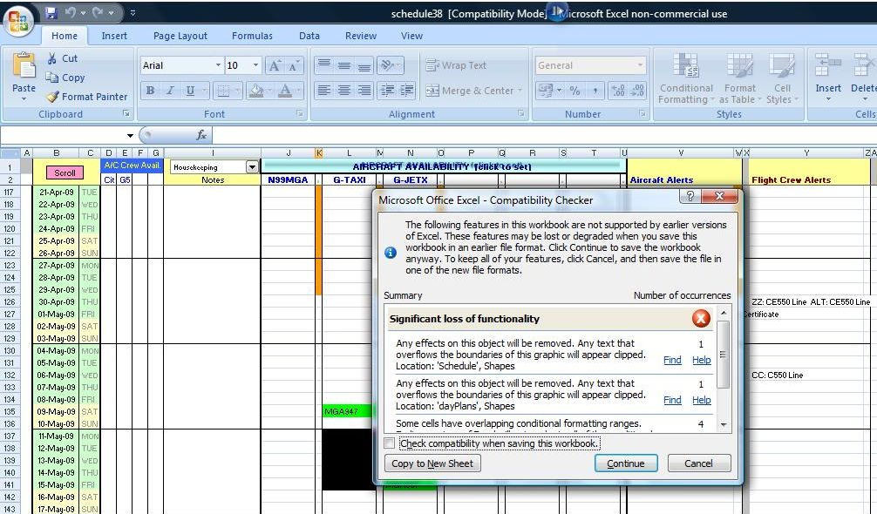
An overview map of the AOC system is available by clicking the ‘map’ Tab:
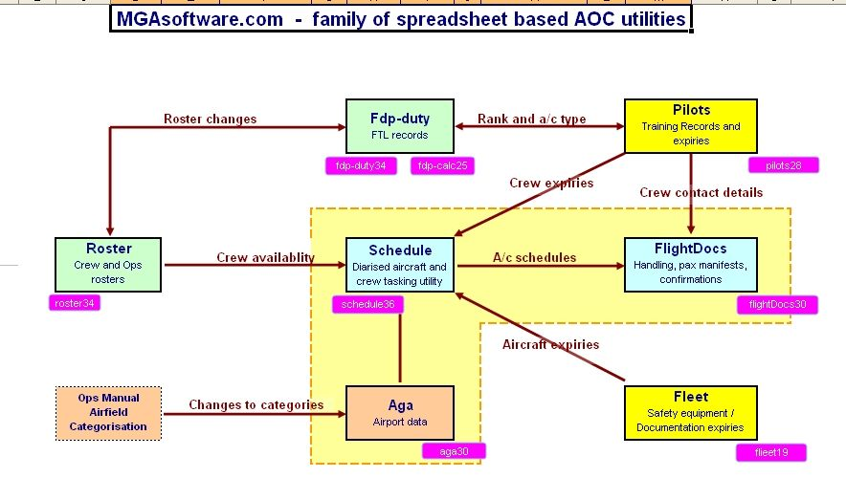

Removing MGAsoftware
Method 1 Using the Installer to remove software
Running the installer program again will present the option to Remove the software.
Place the CD supplied by MGA in the drive. If it does not run automatically then:
Locate the install program on the CD (MGAsoftwareDemo.msi ) and click on it:
This will bring up the installation Set Up screen again:

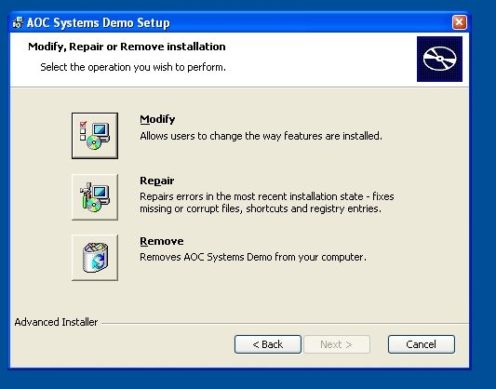
Click the Remove option to begin.
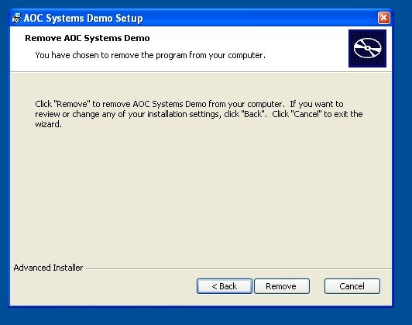

Removing MGAsoftware
Method 2 Using Windows Control Panel

In Excel BEFORE 2007:
Go to Control Panel (Start menu → Settings),
click on Add or Remove Programs.
From the list of programs, select AOC Systems Demo
and then click the Remove button.
In Excel version 2007:
Go to Control Panel (Start menu → Settings),
click Programs
click Programs and Features
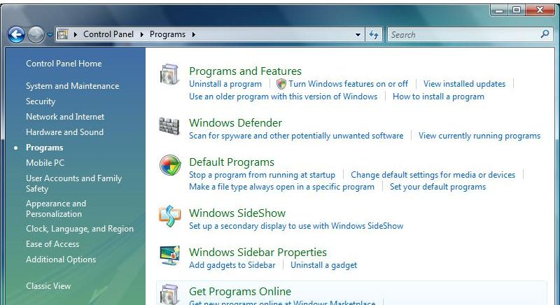
Select AOC Systems Demo and click Uninstall.
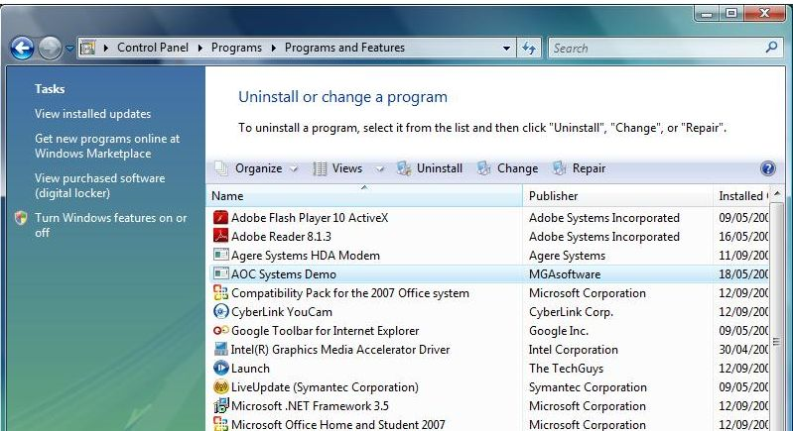

Appendix 1
Help
The following help files are available for MGA modules. These are on the distribution CD and are also copied to your AOC Systems folder on installation. They can be accessed from help buttons within MGA modules or else directly using Windows Explorer. Note the website has pdf versions available.
 | Manual for module(s) | Help File
 | fdp-duty FTL manager & edit utility | Fdp.doc
 | roster operational roster utility | Roster.doc
 | pilots, fleet , aga – Aircrew, aircraft & airports data | Alerts.doc
 | schedule diarised aircraft & aircrew tasking utility | Schedule.doc
Support
AOC Systems software is sold with the latest amendments and comes with a one year 24/7 support package. Email help@MGAsoftware.com or telephone +44 (0) 7791 466201 for support.
General Notes
1 Software distributed by MGA has a version number appended to the module name in the form of a two digit number (eg: ‘21’ = version 2.1). The version numbers displayed on the SetUp screen always corresponds to the filename eg aga23.xls is aga version 2.3.
2 Linked files (those used by another module within the MGA system) are always accessible from the SetUp screen and the current filename is also specified on the SetUp screen. Be aware when an updated module is installed, any module linking to it must have its ‘Linked Files’ entry edited in order to communicate correctly.
3. All MGA modules have Cross folder support installed:
FDP system Flight Duty Periods editing utility (fdp-duty)
Roster Aircrew and Operations rostering
Schedule Diarised aircraft & crew scheduling and alerts
Pilots Aircrew data and validity alerts
Fleet Aircraft database and alerts
Flight Docs Flight Support Documents
aga Airfields database
qed In house examination generator
Cross folder support permits linked modules to reside in remote folders. Filenames may be specified using a relative or absolute syntax. (absolute being those beginning eg: 'C:\'). These modules also give a plain language description of any file errors which occur when the program attempts to open a linked file unsuccessfully.
4. Depending on the version of Excel used, MGA software may cause error flags to display in certain cells. These can be safely disregarded. To switch them off go to Tools > Options, select the Error Checking Tab and uncheck ‘Evaluates to Error Value’.

5. Your company program is tailored to your installation and serves as a management centre for your MGA software program suite. Note that the company program itself does not appear on the module list and has no version number in its filename as do other MGA modules.

Appendix 2
Versions & upgrades

MGAsoftware.com will alert you whenever a substantive revision of your software is available for release.
The latest software will be available for download at MGAsoftware.com (requires ident and password)
To implement an upgrade:
1. Make a safety back up of your existing file using Windows Explorer.
2. Copy your downloaded software into your MGA folder (eg: ‘C:\Program Files\AOC Software’)
3. Run the updated software and from the SetUp screen:
Click ‘Import Data’. .. copy in your data from specified file. (does not apply to fdp-duty module)
Check and reset linked file references.
Excel Folders
The default working folder is automatically defined as the folder containing the company.xls module.
When an Excel file is called up by double clicking on its name in Windows Explorer, a new instance of Excel is invoked which looks for files in its default folder location, not in the folder where the file was called from. This can stop MGA files from obtaining information from other files on boot-up resulting in the following message:
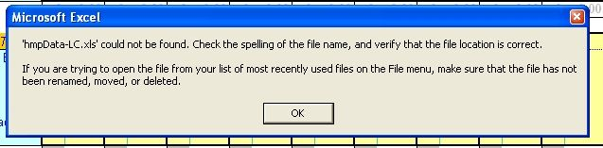
If you see this message, check that the folder you are working by clicking File | Open and using the dialog to navigate to your MGA folder. Click Cancel to exit the dialog. The folder change is registered in Excel whether or not a file is actually opened and the change will last for the current Excel session.
Note: fdp-duty has a SetUp parameter which provides the option to change the working folder of Excel on boot-up in order to circumvent the above problem.
Be aware also that the full path to linked files can be specified on the SetUp screens of MGA modules
Disclaimer: If the validity of your software is time related, MGAsoftware is not responsible for any consequences arising from the use of MGAsoftware after the expiry date.

UK tel: 07791 466201
If you have a software requirement, be aware MGA is happy to investigate the feasibility of bespoke software to your specifics.

